URSI-JRSM 2022 Student Paper Competition:
Instructions for Preparation of a Full-Length Manuscript

S. Yagitani* and Y. Hobara**
* Faculty of Electrical, Information and Communication Engineering, Kanazawa University
Kakuma-machi, Kanazawa 920-1192, Japan
E-mail: yagitani@is.t.kanazawa-u.ac.jp
** Department of Electrical Engineering, The University of Electro-Communications
1-5-1 Chofugaoka, Chofu, Tokyo 182-8585, Japan
E-mail: hobara@ee.uec.ac.jp

Abstract—This material shows how a full-length manuscript for the URSI-JRSM 2022 Student Paper Competition program should be prepared. The Abstract here must be less than 100 words in length.

- Introduction
All applicants for the URSI-JRSM 2022 Student Paper Competition (SPC) program should submit full-length manuscripts in addition to one-page abstracts, both in PDF format, electronically via the conference website (http://www.ursi.jp/conference/jrsm2022/). In the following, we shall provide some details on how a full-length manuscript for the SPC program should be prepared. Note that the full-length manuscript should not exceed 4 pages and its file size should be less than 10 MB.

- Style of Manuscript
  - Organization and page format
The organization of a full-length manuscript and the font style are as follows:
- Title of paper (14 pt. font in bold)
- Names of authors (12 pt. font)
- Affiliation and complete postal/E-mail addresses of each author (12 pt. font)
- Abstract (12 pt. font, heading in bold, em dash “—” should be supplied after the word “Abstract”)
- Introduction (12 pt. font, heading in bold)
- Major sections (12 pt. font, headings in bold)
- Major subsections, if any (12 pt. font)
- Conclusions (12 pt. font, heading in bold)
- Acknowledgments, if any (12 pt. font, heading in bold)
- References (12 pt. font, heading in bold)
The title of paper, names of authors (with the initials and the last names being used), and affiliations and addresses of the authors should be centered. Capitalize each word of the paper title. One blank line should be inserted between the paper title and the names of authors. Note also that two blank lines should be inserted between the postal/E-mail addresses of the authors and the Abstract.
Use A4-size papers in manuscript preparations. Do not number pages. Use the Times New Roman font throughout the manuscript (except equations and symbols). Indent the first line of each paragraph. Single space in the entire text except between consecutive sections and subsections. Double space before and single space after each section/subsection heading. Number all section headings (except Abstract, Acknowledgments, and References) sequentially, beginning with 1. Subsection headings should be numbered as 2.1, 2.2, etc. Capitalize each word of the section headings. For subsections, only the first word of each heading is to be capitalized.

  - Equations
Displayed equations should be numbered consecutively throughout the entire manuscript: (1), (2), (3)…. Do not number equations using section numbers: (2.1), (2.2), (2.3)…. Add one extra line space above and below all displayed equations. Note that all equations should be centered. Place equation number (in parentheses) to the right of the equation.
Parentheses, brackets, and braces should be used in the order {[( )]}. If two brackets of the same kind occur together (e.g., $\left({k\left(x^{2}+y^{2}\right)}^{1/2}\right)$, or $(f(x))^{2}$), something is wrong. Use italic for variables, bold for vectors and matrices, script for transforms, and sans serif for tensors. Use “$exp$” rather than “e” if the argument of an exponential is complicated or lengthy. For some specific mathematical constants and operations, the upright (roman) style, not italic, must be used, such as: Euler’s number ($e=2.71828⋯$), imaginary unit ($i$), ordinary differentiation $\left(d/{dx}\right)$, integration $\left(\int{⋯dx}\right)$.
Note that the word “Equation” (when followed by a number in parentheses) is never abbreviated and is always capitalized. The following Equations - provide an example on how equations should be typeset in the manuscript:

$Φ\left(x,α\right)=\frac{1}{\sqrt{2π}}\int_{-∞}^{∞}{ϕ\left(x,z\right)}e^{iαz}dz, α=Re\left(α\right)+i Im\left(α\right) \left(≡σ+iτ\right)$,

$\left\{\frac{d^{2}}{{dx}^{2}}-{\left[γ\left(α\right)\right]}^{2}\right\}Φ\left(x,α\right)=e^{-iαd}f\left(x\right)+e^{iαd}g\left(x\right), γ\left(α\right)=\sqrt{α^{2}-k^{2}}$,

$A\left(α\right)=-B\left(α\right)+4i\left\{C\left(α\right)\left[F\left(α\right)e^{-2γ\left(α\right)b}-G\left(α\right)e^{-iγ\left(α\right)b}\right]+D\left(α\right)\right\}.$

It is generally preferable to use “in-line” fractions (e.g., ${\left[f\left(x\right)+g\left(y\right)\right]}/h(z)$) instead of “built-up” fractions (e.g., $\frac{f(x)+g(y)}{h(z)}$) in the text. Adequate parentheses and brackets should be used to avoid ambiguity. In displayed equations, it is preferable to use built-up, rather than in-line, fractions:$\left\{\frac{d^{2}}{{dx}^{2}}-{\left[γ\left(α\right)\right]}^{2}\right\}Φ\left(x, α\right)$ instead of $\left\{{d^{2}}/{{dx}^{2}-{\left[γ\left(α\right)\right]}^{2}}\right\}Φ\left(x,α\right)$.
Unless there is an overriding technical reason, the International System of Units (SI) should be used.

  - Figures and tables
All figures and tables should be numbered consecutively throughout the manuscript (not by section). The words “Figure” and “Table” (when followed by numbers) are never abbreviated and are always capitalized. All figures and tables should have captions and be cited in the text.
As an example, Figure 1 and Table 1 show the URSI logo and the URSI-JRSM 2022 Registration Fees, respectively.

Figure 1. URSI logo.

Table 1. URSI-JRSM 2022 Registration Fees.
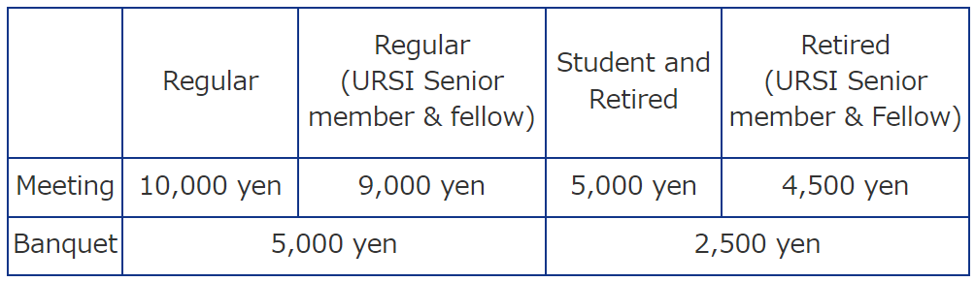

  - References and citations
Each entry in the list of references must have a citation in the text. Citations are enclosed in brackets and are numbered sequentially, in the order in which they appear for the first time in the text: [1], [2, 4], [13-15], etc.
For a journal article [1, 2] in the reference list, each author’s initials followed by the last name are used. Following the last author’s last name is a comma, followed by the full title of the article in curly quotes, the name of the journal in italics, the volume number in bold, the issue number (optional but preferable), the year of publication, and both the beginning and ending page numbers of the article (preceded by “pp.”).
For a book [3], names of authors are followed with the full title of the book in italics, the place of publication, the publisher, and the year of publication, in that order.
For a chapter in a book or an article in a collection [4], names of authors of the article are followed by the full title of the article in curly quotes, the editors, the full title of the collection in italics, the place of publication, the publisher, the year of publication, and the beginning and ending pages of the reference.
For a conference article [5], names of authors are followed by the full title of the article in curly quotes, the full title of the conference proceedings in italics, the year of the conference, and the beginning and ending pages of the reference.

- Conclusions
In this material, we have given instructions for preparation of full-length manuscripts for the URSI-JRSM 2022 Student Paper Competition (SPC) program. Applications are most welcome. Note that authors are responsible for obtaining any and all permissions and releases to use all material used in their manuscripts.
If you have any questions on the SPC program and/or the preparation of a full-length manuscript, please contact Professor Satoshi Yagitani, URSI-JRSM 2022 General Chair at yagitani@is.t.kanazawa-u.ac.jp, or Professor Yasuhide Hobara, URSI-JRSM 2022 Technical Program Committee Chair at hobara@ee.uec.ac.jp.

Acknowledgments
Acknowledgments should be limited to collegial and financial assistance. Acknowledgments are not meant to recognize personal or manuscript production support.

References
- A. Abrardo and G. Ferrari, “A perspective on distributed radio systems with cooperative coding,” The Radio Science Bulletin, 330, 2009, pp. 6-19.
- J. Aarons, R. S. Allen, and T. J. Elkins, “Frequency dependence of radio star scintillations,” Journal of Geophysical Research, 72, 11, 1967, pp. 2891-2902.
- R. Mittra and S.-W. Lee, Analytical Techniques in the Theory of Guided Waves, New York, Macmillan, 1971.
- K. Kobayashi, “The Wiener-Hopf and modified residue calculus techniques,” in E. Yamashita (ed.), Analysis Methods for Electromagnetic Wave Problems, Norwood, MA, Artech House, 1990, pp. 245-301.
- E. H. Shang, J. P. Zheng, and K. Kobayashi, “RCS of a finite parallel-plate waveguide with four-layer material loading,” in Abstracts of the 2009 Progress In Electromagnetics Research Symposium (PIERS 2009 Moscow), 2009, p. 75.

