**2022 URSI-Japan Radio Science Meeting (URSI-JRSM 2022)**

Satoshi Yagitani

Faculty of Electrical, Information and Communication Engineering

Kanazawa University

Kakuma-machi, Kanazawa 920-1192, Japan

Email: yagitani@is.t.kanazawa-u.ac.jp

The “URSI-Japan Radio Science Meeting” (URSI-JRSM) is the URSI conference organized by the Japan National Committee of URSI. The URSI-JRSM provides a regional scientific forum for radio scientists and engineers in Japan and the Asian region. The objective of the Conference is to review current research trends, present new discoveries, and make plans for future research and special projects in all areas of radio science, and a particular emphasis is placed on enhancing the visibility of URSI in the Asian countries and encouraging young scientists to contribute to various URSI activities.

The “2022 URSI-Japan Radio Science Meeting” (URSI-JRSM 2022) is the third URSI-JRSM and will be held on September 1-2, 2022 at Chuo University, Tokyo, Japan. The scientific program will consist of oral sessions, a poster session, keynote lectures, and invited talks, which include topics covered by the URSI Commissions A-K:

Commission A: Electromagnetic Metrology

Commission B: Fields and Waves

Commission C: Radiocommunication Systems and Signal Processing

Commission D: Electronics and Photonics

Commission E: Electromagnetic Environment and Interference

Commission F: Wave Propagation and Remote Sensing

Commission G: Ionospheric Radio and Propagation

Commission H: Waves in Plasmas

Commission J: Radio Astronomy

Commission K: Electromagnetics in Biology and Medicine

Every author submitting a paper should prepare a one-page abstract of the paper as a PDF file, with the file size not exceeding the 5 Mbyte limit.

Table 1. Registration fees.

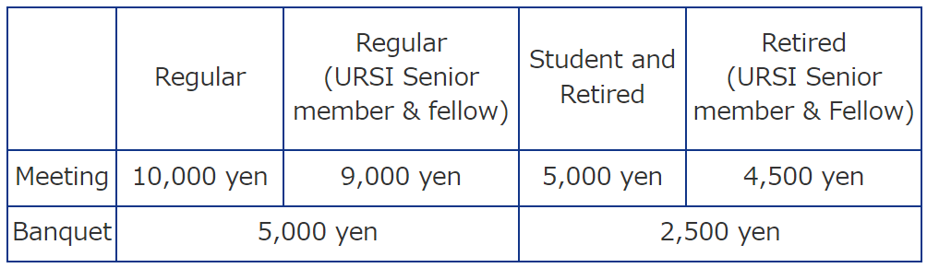



Figure 1. URSI logo mark.

**References**

1. URSI-JRSM 2019 Website, http://www.ursi.jp/conference/jrsm2019/.
2. K. Kobayashi, and S. Yagitani, “Introduction to special issue of the 2015 URSI-Japan Radio Science Meeting,” Radio Science, No. 52, pp. 430-431, April 2017.